Oil Palette knife with Maria Iva
List of supplies:
- 2 Palette knives (with FLEXIBLE blades 3 cm and 4.5 cm long diamond shape) See picture below. 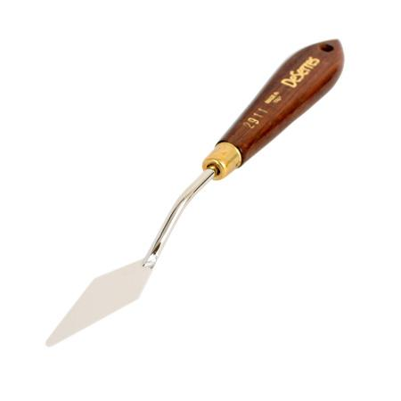
- stretched canvas, Canvas panel, canvas board or gessoed board sizes: 12x12, 14x14, 16X16
- Easel (table or stand easel)
- Palette
- sketchbook
- Pencil
- eraser
- Paper towels
- Baby wipes
- Trash bag
- Apron
- Basic palette of colors (titanium white, cool and warm cad yellow, yellow ochre, cad orange, red (Permanent Rose or Cad Red or Alizarin Crimson), burnt sienna, ultramarine blue, cerulean blue, turquois green (or veridian green), purple or violet. Bring big tubes as we will use a lot of paint especially White and Ultramarine Blue. Buy cheap paint. I use Van Gogh brand. Winton is good too.

