Oakville Art Society
Wiring and Label Requirements for Art Shows
March 2026

Wiring:

All artwork must have D-hooks and wire attached on the backside for hanging. Art without proper hanging hardware will not be accepted as we cannot guarantee the safety of your art after it has been hung. Sawtooth hangers are not acceptable.
The tightened wire should not appear above the top of the artwork. A rule of thumb is to have the top of the tightened wire no more than 1” below the top of the frame for small works and 2” below the top of the frame for larger works. Rings and screws should be about 4” or ¼ of the total height down from the top of the frame (see below).
Please wrap any sharp edges of the wire with tape as a courtesy to those hanging your art.



4” or ¼ of total height

2
”

Labe
l

D
D

Photo of D-Ring (available at hardware stores and art stores):

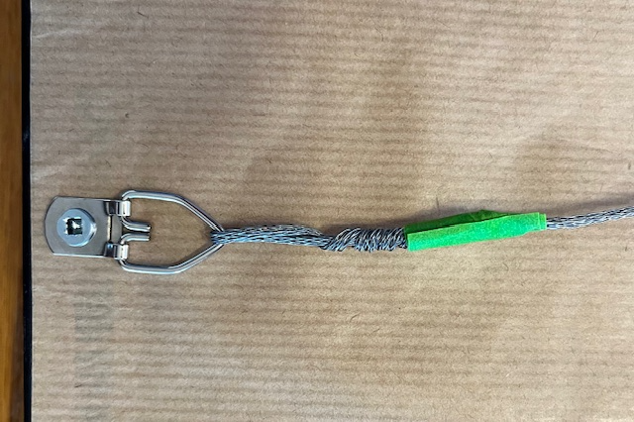

Photo of back of painting with D-rings, wire and tape installed. | 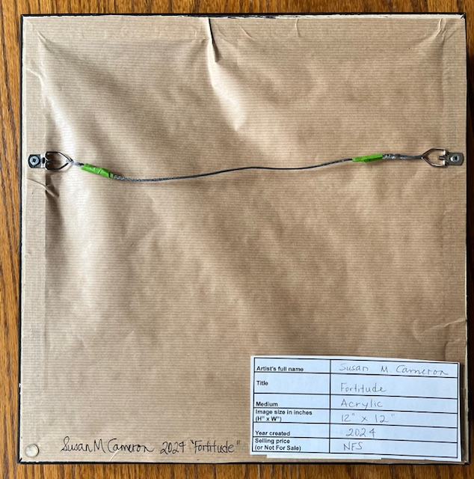

Labels: Each exhibiting artwork must have one label attached to the back of the painting. Attach one label firmly to the back per the diagram above. Masking tape or painters’ tape is suggested, so as not to damage anything.
It’s also recommended that your name, title and year created be printed on the back of your artwork in case this label becomes detached from the artwork.

Artist’s full name
Title

Medium
Image size in inches
(H” x W”)
Year created
Selling price
(or Not For Sale)

