**Oil Palette knife with Maria Iva**

**List of supplies:**

* 2 Palette knives (with blades 3 cm and 4.5 cm long diamond shape) See picture below. 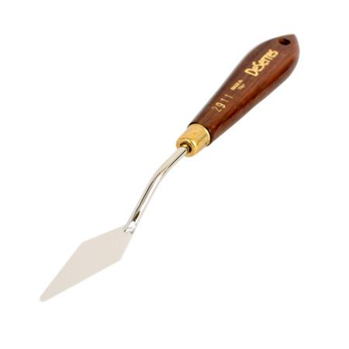
* stretched canvas, Canvas panel, canvas board or gessoed board sizes: 14x14 or 16X16, or 18x18.
* Easel (table or stand easel)
* Palette
* sketchbook
* Pencil
* eraser
* Paper towels
* Baby wipes
* Trash bag
* Apron
* Basic palette of colors (titanium white, cool and warm cad yellow, yellow ochre, cad orange, red (Permanent Rose or Cad Red or Alizarin Crimson), burnt sienna, ultramarine blue, cerulean blue, turquois green (or veridian green), purple or violet. Bring big tubes as we will use a lot of paint especially White and Utramarine Blue.